**ZUITT NOTES – DAY 22** 2/7/2023

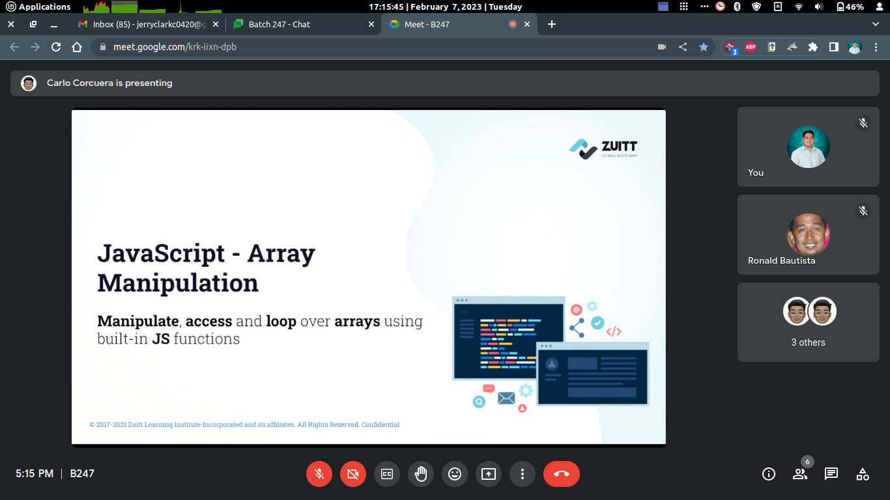

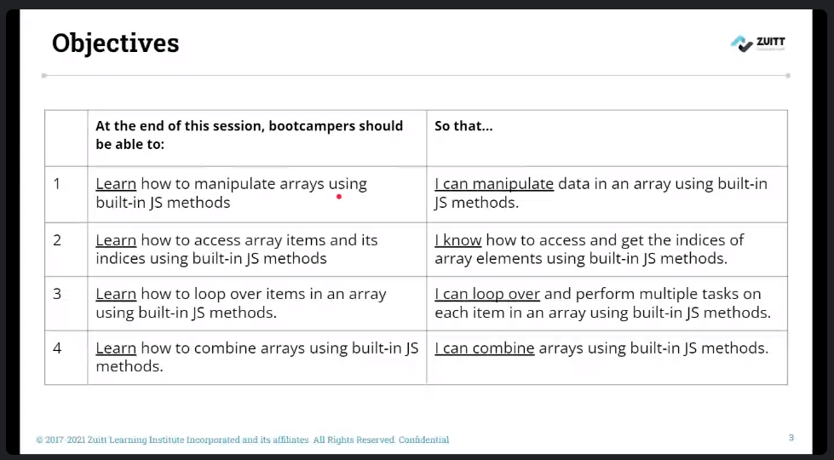

1. In the S22 folder, create an activity folder, an index.html file inside of it and link the index.js file.

2. Create an index.js file and console log the message Hello World to ensure that the script file is properly associated with the html file.

3. Copy the activity code and instructions from your Boodle Notes into your index.js.

4. Create a function which will allow us to register into the registeredUsers list."

This function should be able to receive a string.

Determine if the input username already exists in our registeredUsers array.

If it is, show an alert window with the following message:

"Registration failed. Username already exists!"

If it is not, add the new username into the registeredUsers array and show an alert:

"Thank you for registering!"

Invoke and register a new user in the browser console.

In the browser console, log the registeredUsers array.

5. Create a function which will allow us to add a registered user into our friends list.

This function should be able to receive a string.

Determine if the input username exists in our registeredUsers array.

If it is, add the foundUser in our friendList array.

Then show an alert with the following message:

"You have added <registeredUser> as a friend!"

If it is not, show an alert window with the following message:

"User not found."

Invoke the function and add a registered user in your friendsList in the browser console.

In the browser console, log the friendsList array in the console.

6. Create a function which will allow us to show/display the items in the friendList one by one on our console.

If the friendsList is empty show an alert:

"You currently have 0 friends. Add one first."

Invoke the function in the browser console.

7. Create a function which will display the amount of registered users in your friendsList.

If the friendsList is empty show an alert:

"You currently have 0 friends. Add one first."

If the friendsList is not empty show an alert:

"You currently have <numberOfFriends> friends."

Invoke the function in the browser console.

8. Create a function which will delete the last registeredUser you have added in the friendsList.

If the friendsList is empty show an alert:

"You currently have 0 friends. Add one first."

Invoke the function in the browser console.

In the browser console, log the friendsList array.

9. Create a git repository named S22.

10. Initialize a local git repository, add the remote link and push to git with the commit message of Add activity code.

11. Add the link in Boodle.

Activity - How you will be evaluated:

1. No errors should be logged in the console.

2. All function objectives are met.

3. Array methods are appropriately used.

4. All values must be properly logged in the console.

5. All variables are named appropriately and defines the value it contains.

6. All functions are named appropriately and follows naming conventions.

